# Cloud Flows

Create a cloud flow when you want your automation to be triggered either automatically, instantly, or via a schedule.

This video gives an overview of cloud flows.

| **Flow type** | **Use case** | **Automation target** |
| --- | --- | --- |
| [**Automated flows**](https://learn.microsoft.com/en-us/power-automate/get-started-logic-flow) | **Create an automation that is triggered by an event such as arrival of an email from a specific person, or a mention of your company in social media.** | [**Connectors**](https://learn.microsoft.com/en-us/connectors/)**for cloud or on-premises services connect your accounts and enable them to talk to each other.** |
| [**Instant flows**](https://learn.microsoft.com/en-us/power-automate/mobile/mobile-create-flow) | **Start an automation with a click of a button. You can automate for repetitive tasks from your desktop or mobile devices. For example, instantly send a reminder to the team with a push of a button from your mobile device.** | **Wide range of tasks such as requesting an approval, an action in Teams or SharePoint.** |
| [**Scheduled flows**](https://learn.microsoft.com/en-us/power-automate/run-scheduled-tasks) | **Schedule an automation such as daily data upload to SharePoint or a database.** | **Tasks that need to be automated on a schedule.** |

**Find your flows easily**

You might have a need to find a flow within a large number of flows. Finding your flows is easy—just use the search box on the **My flows**, **Team flows**, **Connections**, or **Solutions** screen to display only flows that match the search terms you enter.

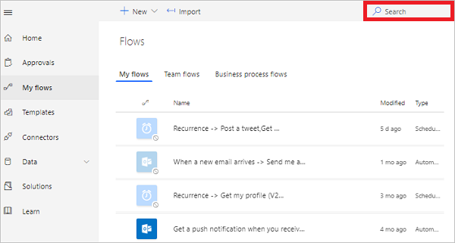

**Note**

The search filter only finds flows that have been loaded into the page. If you don't find your flow, try selecting **Load more** at the bottom of the page. If you're ready to start your Power Automate project, go to [**Introduction: Planning a Power Automate project**](https://learn.microsoft.com/en-us/power-automate/guidance/planning/introduction) to get up and running quickly.